Building keyword recognition into DFAs is not conceptually difficult but considerably increases the number of states and transitions. The key fact about usual keywords is that an identifier may contain an initial segment or the whole of a keyword; e.g., "whil", "whil5", "whilea", etc. Based on this observation the following method can be used:

* Create a linear sequence of transitions for each keyword; any non-empty, proper initial segment of each keyword is accepted by a final state as an identifier.
* Whenever the input letter or digit breaks a keyword, the transition branches off to the <id> state.
* The final state for each keyword has the transition to the <id> state on the letters and digits.

The following is a DFA to accept <id> and the keyword "if":

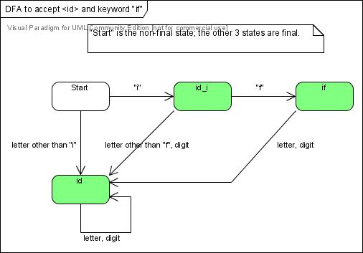

Modify this DFA to accept additional keywords "else" and "while".